Getting started with Office 365
What is Office 365?
Office 365 is a brand name Microsoft uses for a group of software and services as well as online versions of office products, for example Word. This is available to all students in Horizons.
Key Concepts
Office 365 is the overall brand name for the. This gives access to online apps and cloud storage
Office 2016 is the latest group of applications made up of Word, Excel, PowerPoint, OneNote, Access, Publisher and Outlook. It is available for PC or Mac with apps available for phones and tablets.
Office online is a series of online apps that run in a browser such as Chrome. They do not require the full applications to be installed on the machine and so can be used from almost any computer with an internet connection. Apps include Outlook, OneDrive, Word, Excel, PowerPoint, OneNote, Teams, Sway, Planner and more. See the section later in this leaflet.
Full apps vs online apps. The online apps are reduced in what they can do compared to the full version. Features can be displayed in both, but some features can only be added or edited using the full, installed application. For example, a Word file stored in online can be opened in Word Online and edited using basic features. For more advanced features, the file can be opened in Word desktop app provided it is available on the device.
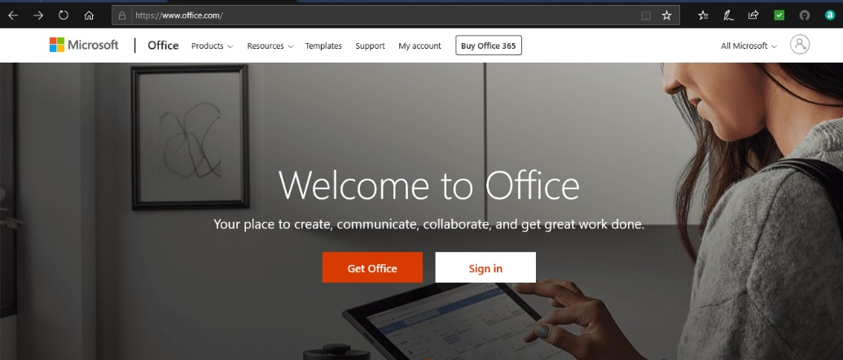
Logging in using the Office 365 portal

Go to www.office.com using a web browser (like Google Chrome, Microsoft Edge or Mozilla Firefox) and if requested enter your full school email address and your regular school password. Your email address may be in the following format:
Westlands: firstname.surname@wl.horizonstrust.org.uk
Mo Mowlam: firstname.surname@mm.horizonstrust.org.uk
Hollis: firstname.surname@ha.horizonstrust.org.uk
Green Gates: firstname.surname@gg.horizonstrust.org.uk
Abbey Hill (inc. 6th Form) firstname.surname@ah.horizonstrust.org.uk
For older addresses try: firstname.surname@horizonstrust.org.uk
Office 365 settings
There are many settings in Office 365. Two of the most commonly requested are:
Mail - Focused Inbox - to decide if there is one inbox or if Outlook will automatically sort mail by relevance
OneDrive - Site Settings - Region - which can affect the file times displayed if set to the incorrect region
Word Online
A new blank document can be created in Word Online, as long as you are logged into Office 365 any changes will be saved and will be accessible online. If you want to use some of the extra features available in the app, such as section breaks, the file can be opened in Word on your device. Trust computers have Office 2016 already installed. You will need to install Office 2016 to your own device in advance. Use the ellipsis next to the file to open in Word.
Office 365 Apps available
Select the app launcher to view the apps available to you and select All Apps to see the full list.
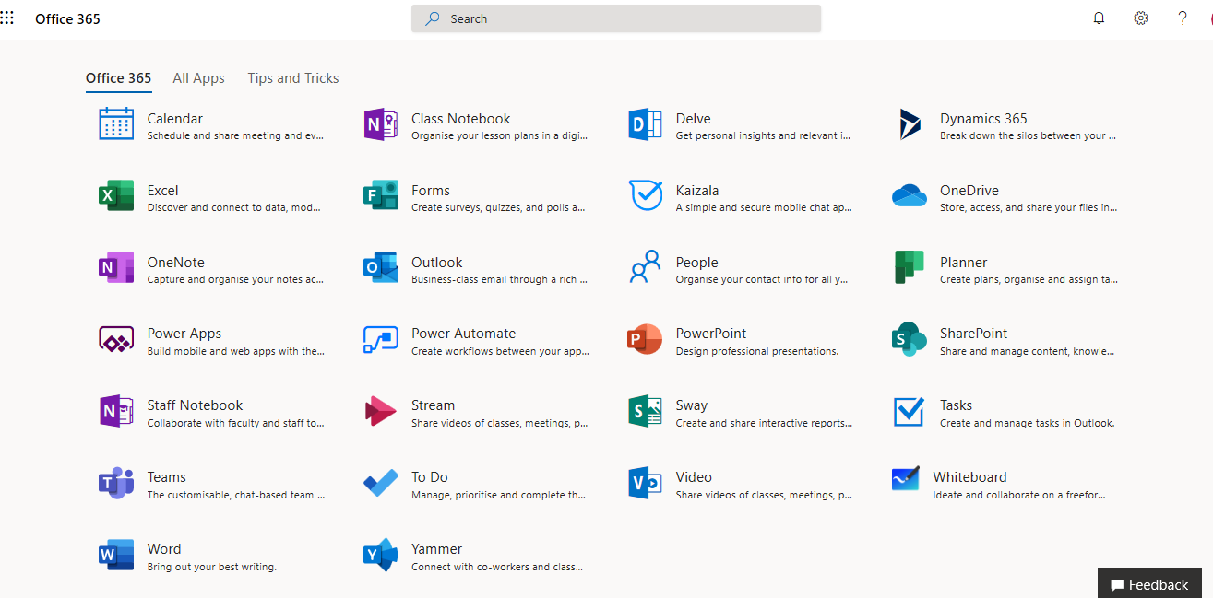
Apps available as of September 2019. Others may also be added:
Calendar - Part of Office 365 email.
Excel - Spreadsheet for data storage and analysis
Forms - Create surveys, quizzes and polls.
OneDrive - Online storage for files
OneNote - Capture notes, shared across all your devices
Outlook - Email for students
People - Contacts
PowerPoint - Presentations
Sway - Card based, responsive presentations
Tasks - Tasks linked to Outlook email
Teams - Customisable, chat-based team workspace with shared tools
To-Do - Simple to-do list
Word - Word processing

